Temperature, Frequency and Young’s Modulus of a Wineglass

Amitta Miller and Rachel Seng

International School Bangkok,
39/7 Samakee Rd, Pakkret,
Nonthaburi, 11120, Thailand
Email: rachelseng@yahoo.com.sg

Abstract
A crystal soda-lime wineglass, heated to temperatures ranging from 25 °C to 150 °C, was tapped and the frequency recorded. It was shown that the relative change in the frequency at different temperatures can be used to determine the effect of temperature on Young’s Modulus of the glass. This simple method of tapping a wineglass is proposed as an effective way of determining the relative effect of temperature on Young’s Modulus of glass.

Keywords: wineglass, temperature, frequency, Young’s modulus

I. INTRODUCTION

Young’s Modulus, also known as the Modulus of Elasticity, is a measure of the ‘stiffness’ of an elastic material. It can be measured by sending an ultrasonic longitudinal pulse through the material and measuring the time of flight, as Young’s Modulus (E) depends on the density of the material (ρ) and the longitudinal velocity of the pulse (v), according to the equation:
E = ρv² (1)
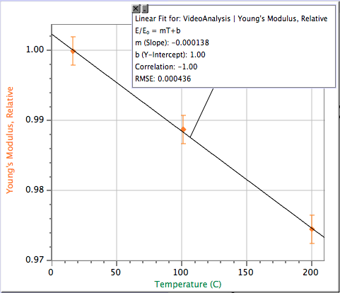
It can also be measured using freely vibrating rods to determine the elastic constants, or through free resonance by impulse or continuous excitation. Although equation 1 seems relatively simple, the measurement of Young’s modulus typically requires sophisticated apparatus including rods with rectilinear or circular cross sections, microphone sensors and contact sensors, along with calculations of Poisson’s ratio and the Shear Modulus¹. Adding the variable of temperature, experimental measurements for Young’s Modulus become even more complicated. The purpose of this paper is to suggest a simple alternative method for measuring the relative effect of temperature on Young’s Modulus of glass using a wineglass.
Figure 1. Ratio of (E/E₀) for glass graphed against temperature, E₀ being the E at 0°C.²

In a similar investigation by Greer, the effect of temperature on Young’s Modulus of aluminum was accurately determined using a tuning fork and microphone. With just this simple apparatus, the researcher was able to match published results.² This paper presents an extension of Greer’s research using a wineglass instead of a tuning fork.
The relation between Young’s Modulus of glass and temperature that was measured by Matsuda³ is shown in Figure 1, where the E values relative to E at 0 °C is graphed against temperature to obtain a slope of -0.000138, showing that the relative (%) decrease in E for every degree Celsius increase is 0.0138 $\frac{ \%}{°C}$.

Wine glass resonance frequency is related to Young’s Modulus according to the equation:

$f_{0}=\frac{∝}{2πR_{out}}\sqrt{\frac{E}{ρ(1-σ^{2})}}$ (2)

in which $f_{0}$represents the resonance frequency, $ρ$ the density,$σ$ the Poisson ratio, E the Young’s Modulus of the material, and $∝$ is a parameter dependent on the outer and inner radii of the wineglass.⁴ This shows that f² is proportional to E, when all other factors are held constant.

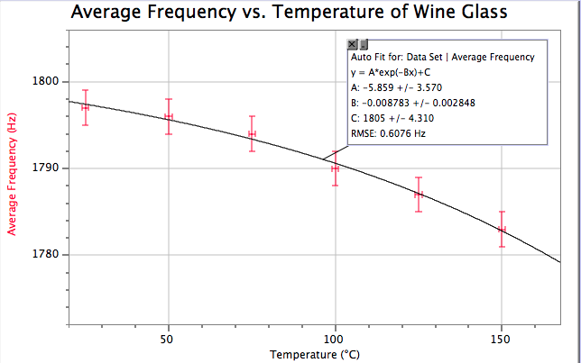
The frequency at which wine glasses resonate is affected by temperature. In this research, a new, simpler method of determining the relative effect of temperature on Young’s Modulus is being proposed. The frequency produced by a cylindrical wine glass at different temperatures will be measured. If the results match figure 1, then we suggest that it is possible to determine the relationship between temperature and Young’s Modulus of glass using simple and inexpensive equipment such as a microphone and a wineglass.
Figure 3. An exponential relationship between the temperature and the average frequency is shown.

II. METHODS

A cylindrical wineglass, shown in figure 2, was used. The wineglass was made of crystal soda-lime glass of unknown composition. A wooden pencil was hit against the wall of the wine glass in a sharp stroke to create a clean ringing sound that was recorded with a Vernier microphone at 100,000 samples per second. The frequency of the lowest harmonic was determined using a Fast Fourier Transform function. The wineglass was then placed in an oven, and heated to temperatures ranging up to 150 °C. After the wineglass reached the desired temperature, the oven door was opened, the glass was quickly tapped and the sound recorded. Three trials were recorded at each temperature.

III. RESULTS AND DISCUSSION

Figure 3 shows that the relationship between the temperature and the average frequency is:

$f=-5.8 e^{0.0087 T}+1805Hz$ (3)

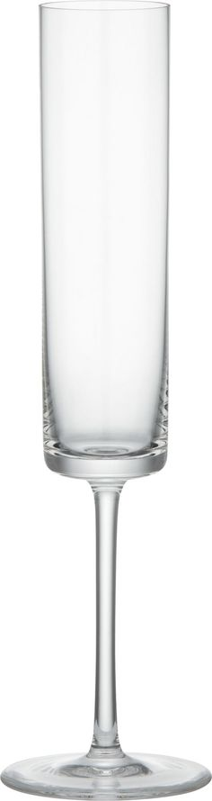
From this, the ratio of the square of the frequency at each temperature to the square of the frequency at the lowest temperature, ($f$²/$f_{0}$²), was graphed against temperature in Figure 4. According to Equation 2, apart from E, all other values remain relatively constant, as percentage changes in size and density as a result of expansion are much smaller compared to changes in E for the range of temperature (T) tested. It can be assumed that changes in frequency are predominantly caused by changes in E. The slope of the graph in Figure 4 will therefore be the same as the slope of the E vs. T graph, showing the relative change in Young’s Modulus as a function of temperature. The equation derived from figure 4 is:
46.85± 0.05 mm
13.4 ± 0.1 cm
8.8 ± 0.1 cm
Figure 2. Dimensions of the wineglass used. The walls of the glass were 1.70 ± 0.05 mm thick.

$\frac{f^{2}}{f_{0}^{2}}=0.00013 T+1.0$ (4)

Figure 4 matches Figure 1 within uncertainties, having a slope within 7% of Matsuda’s results. This

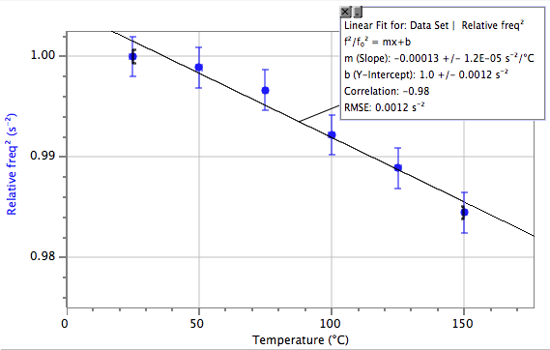
discrepancy could have been caused by the use of crystal soda-lime glass for this research, and not common soda-lime glass as was used in Matsuda’s investigation. This result supports the claim that E is proportional to $f$², and the relative change of $f^{2}$is equal to the relative change in E of a similar glass.
Figure 4. The relationship between the ratio of $f$²/$f_{0}$² and temperature.

We have shown that relative changes in E caused by temperature can be determined with the simple method of tapping a wine glass and measuring the resonant frequency, for temperatures range from 25 °C to 150 °C. The wine glass, with its irregular and complex shape, produces complex standing waves very different from that of a rod or an oscillating tuning fork. Despite this, the relationship between its resonant frequency and Young’s Modulus is the same as it is for the simple shapes typically used.

One of the major methodological issues is the consecutive data collection for each temperature, as the heat loss to the environment – especially at higher temperatures – contributed the most to the uncertainty of the collected data. Although this issue cannot be completely eliminated for this technique, it can be reduced by closing the oven door and reheating the wine glass after each trial.

Further research is suggested using different shapes of glass, as well as with different types of glass and other resonating objects, to widen the range of understanding of this topic.

IV. CONCLUSION

It has been shown that the relationship between E and $f^{2}$ is proportional, allowing for relative changes in E caused by temperature to be determined by the simple method of tapping a wine glass. This suggests that it is possible to measure the relative effect of temperature on E for any material that resonates, using an object made from that material.

REFERENCES

- Czichos, H., Smith, L., & Saito, T. (2011). Springer Handbook of Metrology and Testing (2nd ed.). Heidelberg: Springer-Verlag Berlin Heidelberg.

- Greer, Z. (2011). Temperature, Frequency and Young’s Modulus of an Aluminum Tuning Fork. International School Bangkok Journal of Physics, 5(1), 1-4.

- Matsuda, J. (1960). Studies on the Young’s Modulus of Silicate Glass as a Function of Temperature. The Review of Physical Chemistry of Japan, 30(1), 9-24.

- Xie, Y. (2003). UHF micromechanical extensional wine-glass mode ring resonators. Electron Devices Meeting, 2003. IEDM '03 Technical Digest. IEEE International, 39.2.1-39.2.4. doi:10.1109/IEDM.2003.1269436

